Home Page:
- Update Entire wordings of Box “Our Vision” will be replaced. The content is provided in separate document. Below screenshot where updated is needed.
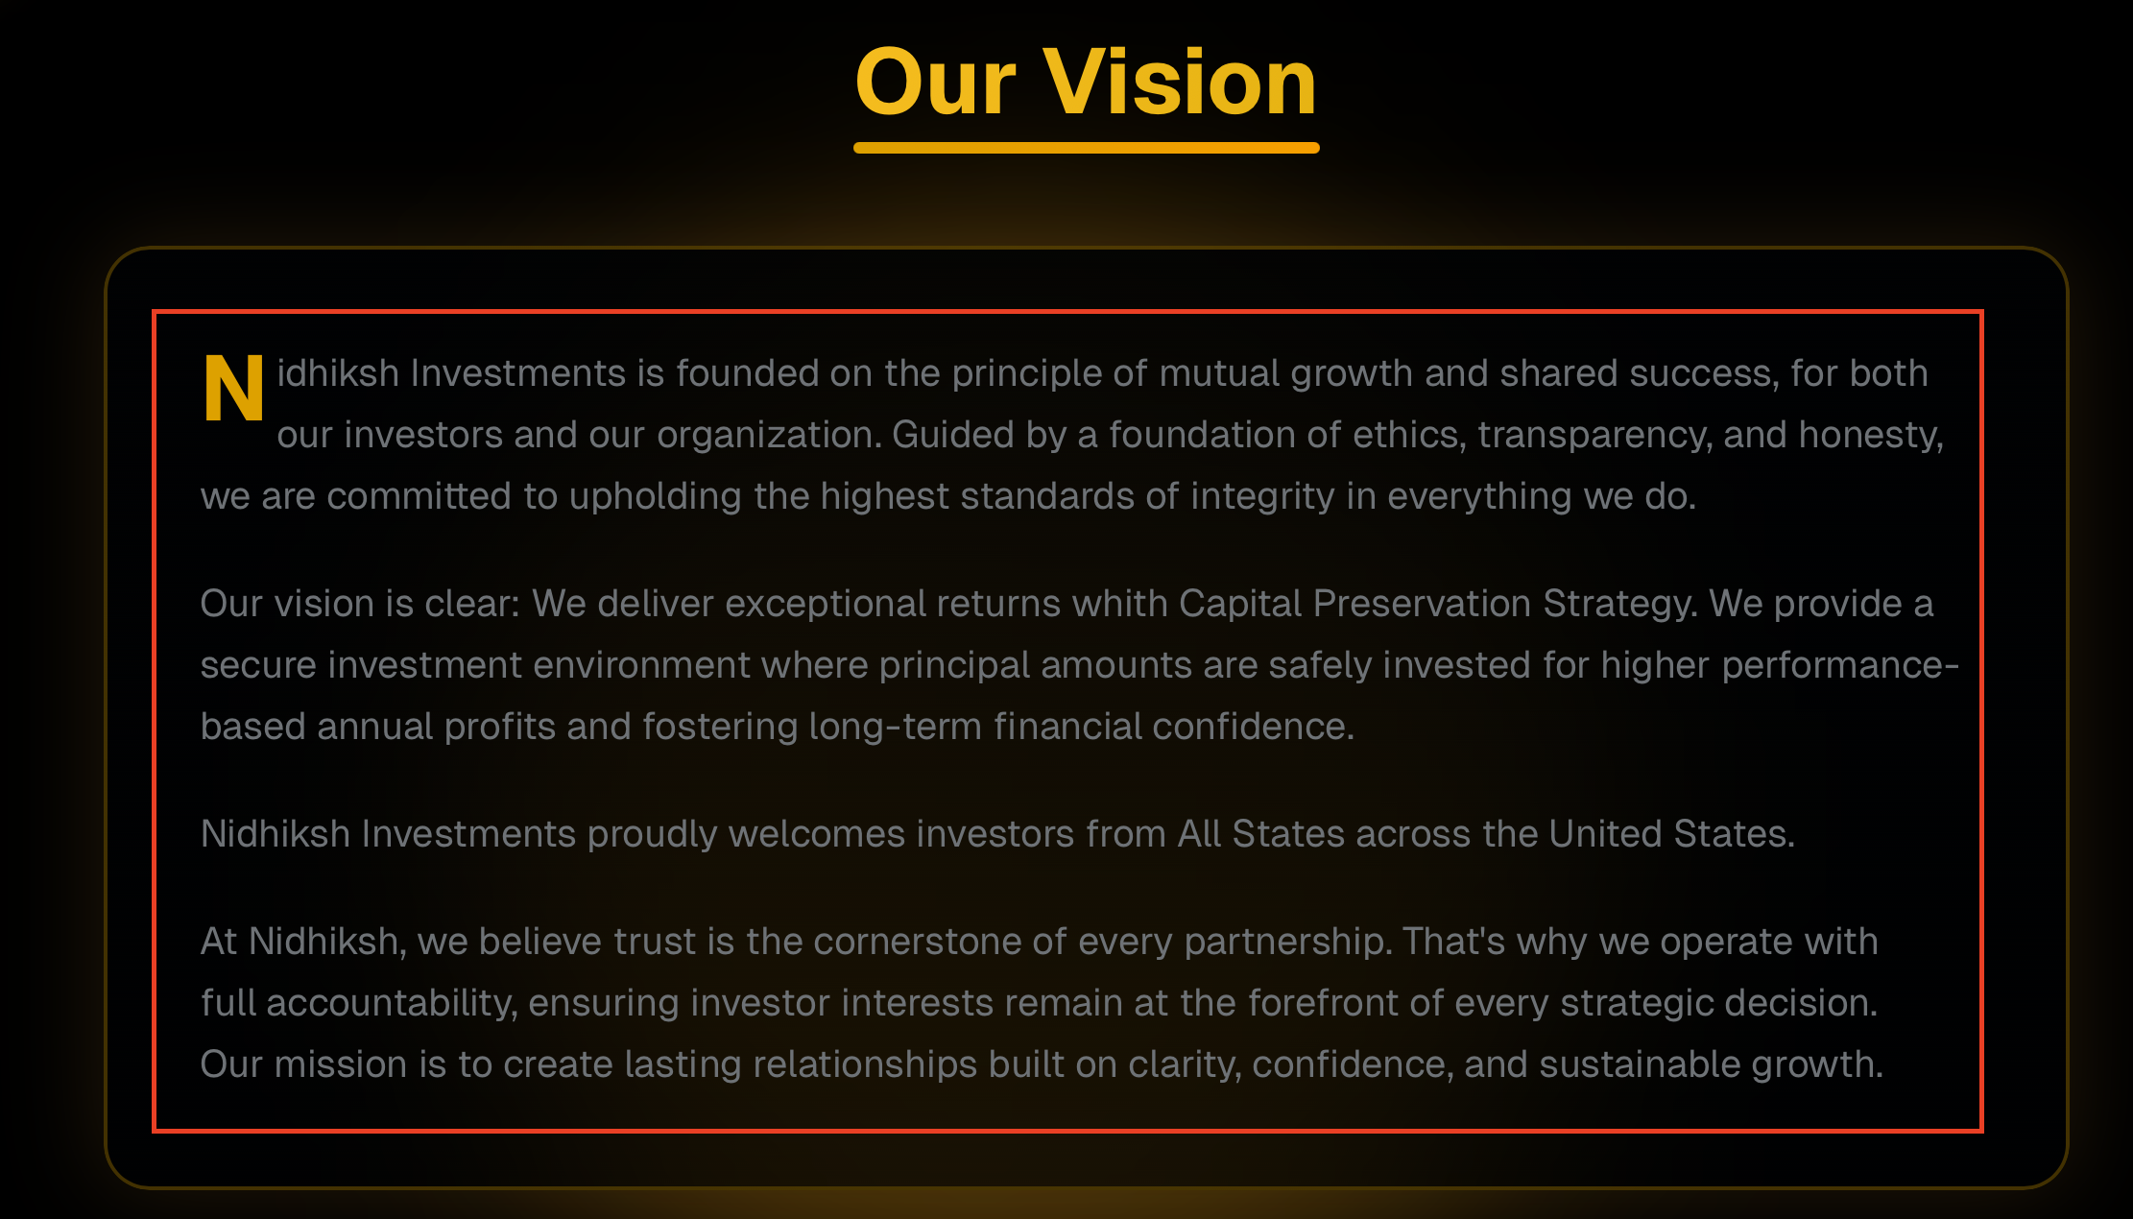

- Why Choose Nidhiksh? : Update content from PPT Slide.
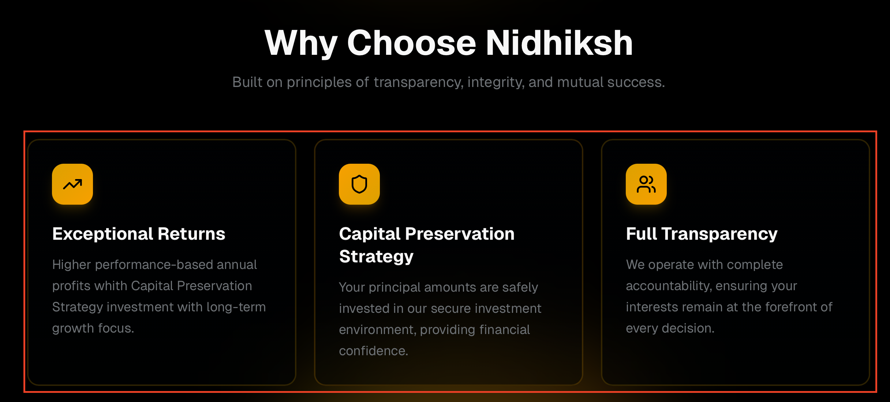

About Us:
- Entire wordings of Box “About Us” will be replaced.
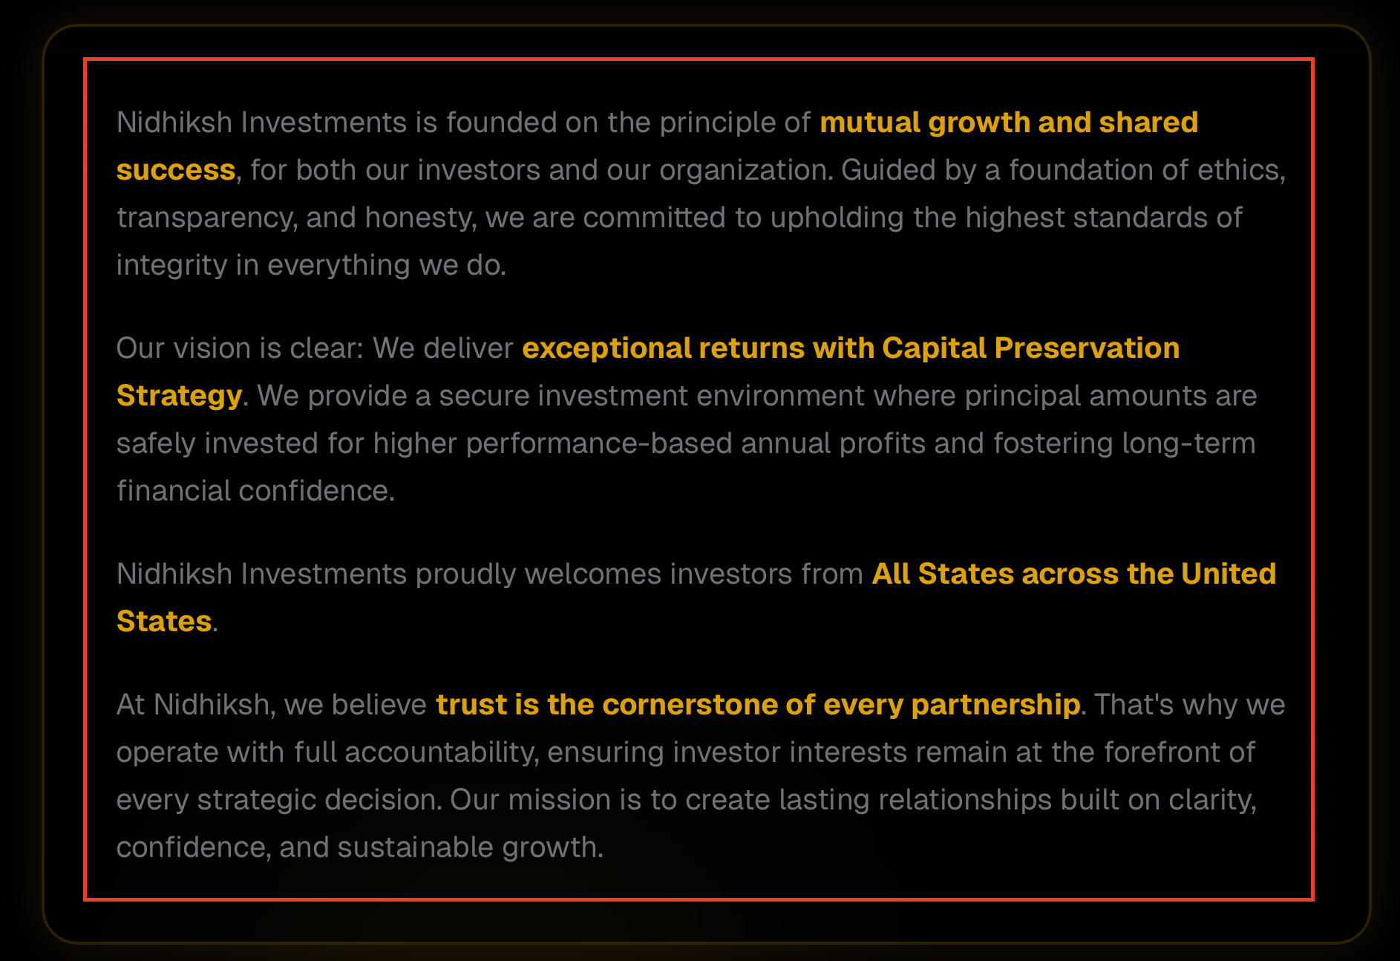
- Our Core Values: Update content from PPT Slide.
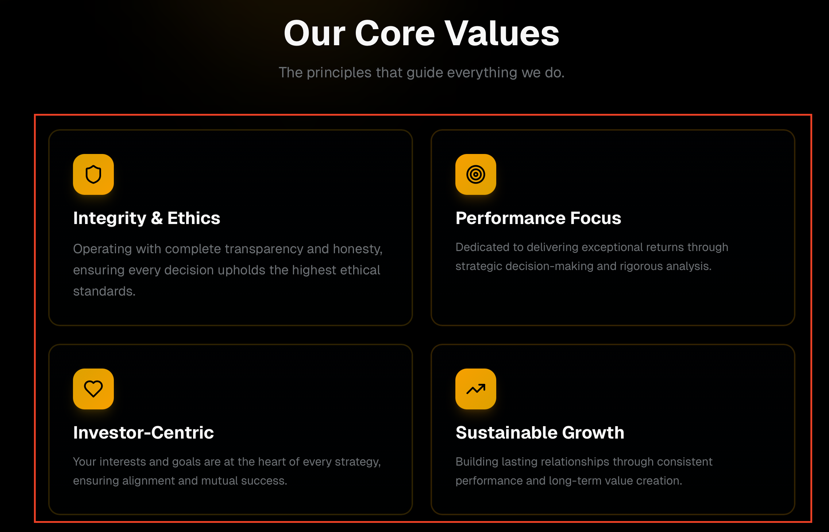

- Update All Team Member Picture, their Title, and their Bio. So we will have a Picture with Title. For Bio, (Know About Vishal Patel), text – if you click that text box, Bio Page will open.
Invest:
- What you get? : Update content from PPT Slide + Replace “What You Get” with “Seamless Onboarding - A Disciplined 5-Step Approach”
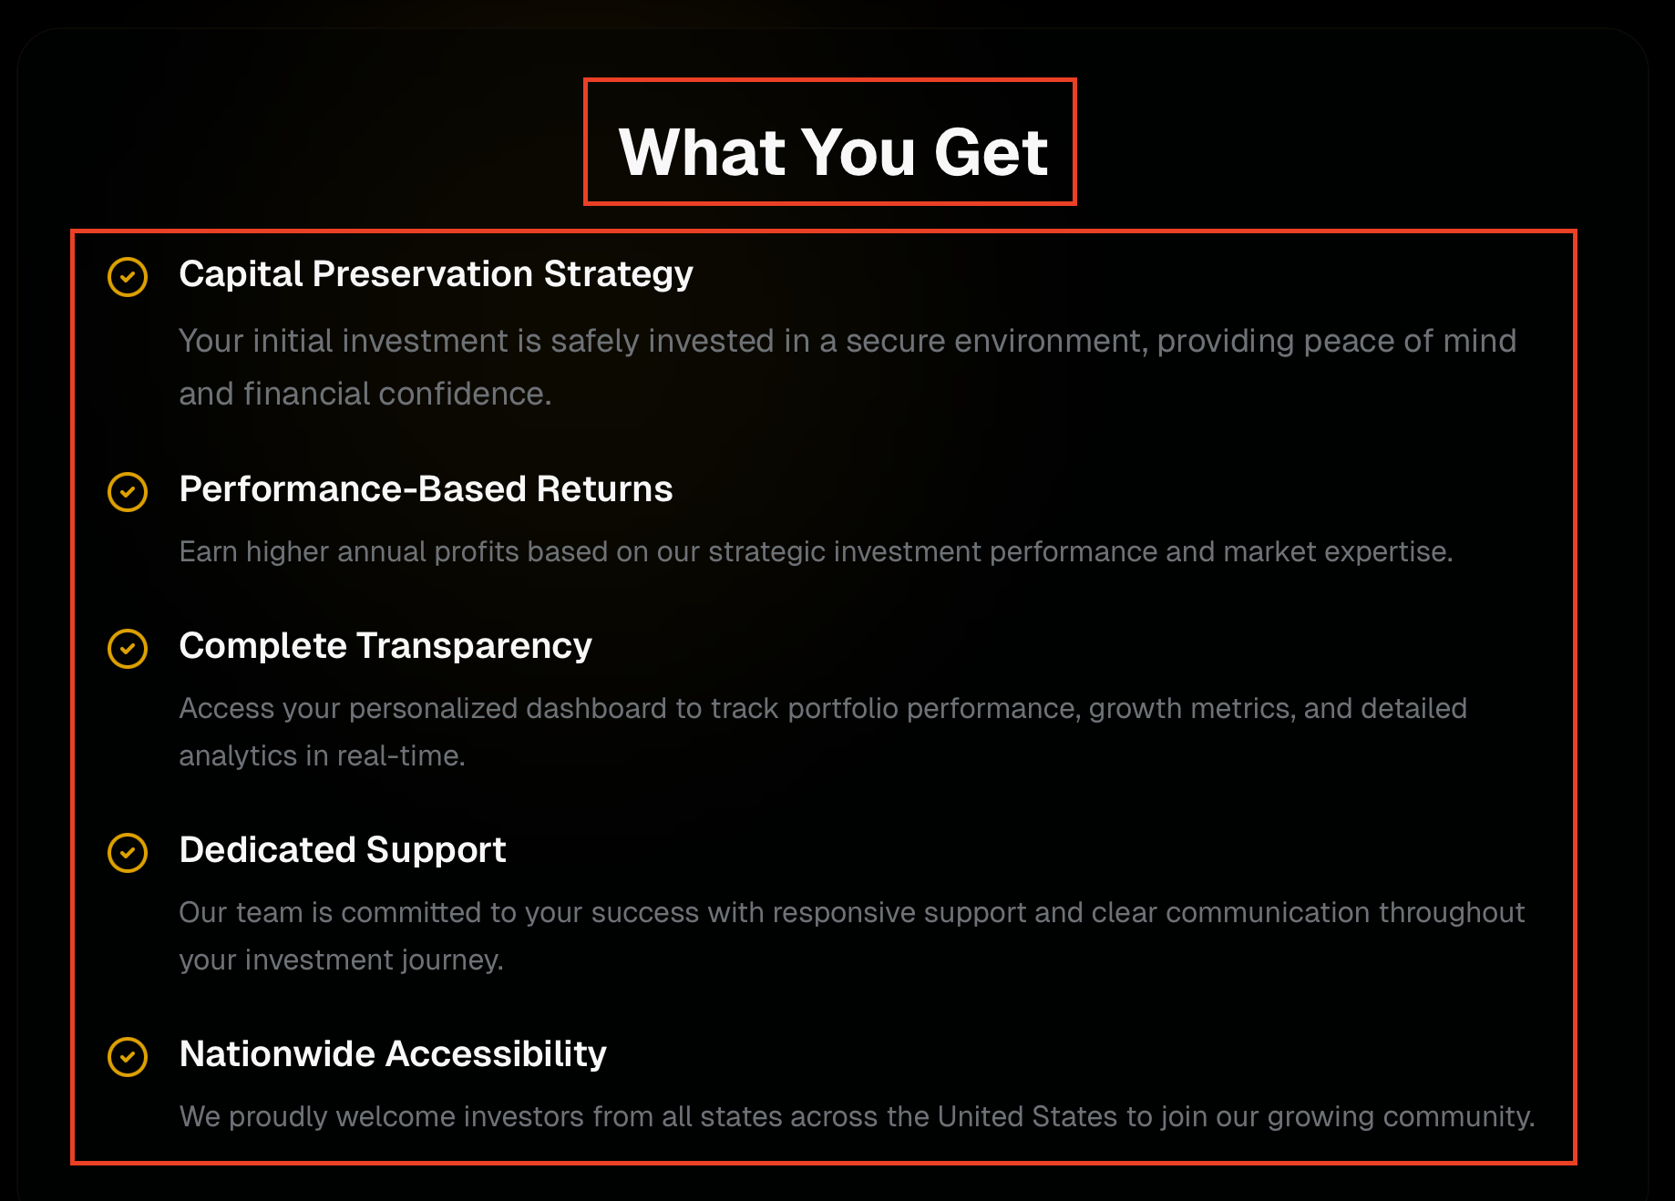

Footer:
- Privacy Policy: Text is clickable, and content opens in separate page
- Disclosure: Text is clickable, and content opens in separate page
- Terms Of service: Remove this text

